How to Opt-In to SAGE SMS Messaging

Step One: Log into SAGE.

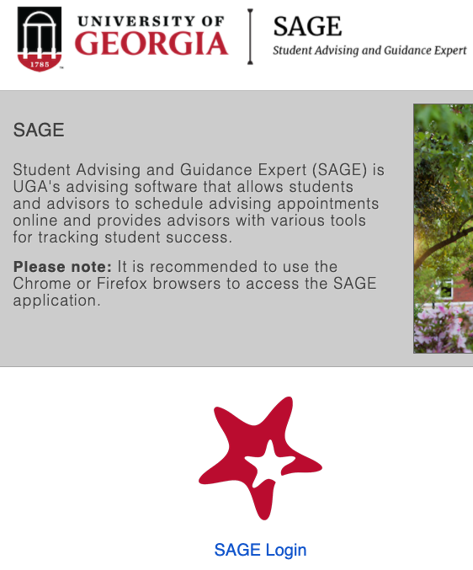
Step Two: Go to the three horizontal lines (hamburger menu) in the upper left-hand corner and click it to open your SAGE menu.


Step Three: Open the menu and select the down arrow by your name and then select “Edit Profile.”



Step Four: Scroll to where it says “Contact Information.” Cell Phone is the fifth box under that heading.

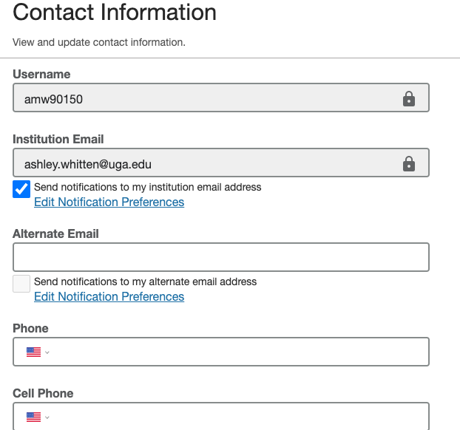

If you listed your cell phone number when you applied to UGA, it should be automatically populated so double check that it is correct! If it isn’t listed or is incorrect, edit it so it is displaying your cell phone # correctly.

Step Five: Check the box that says, “Send text notifications to my cell phone.”

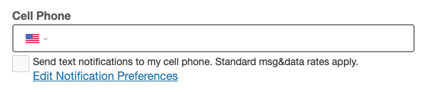

After this, you are all good to go and you will now receive SMS messaging from SAGE regarding important things going on in advising and messages from your advisor! (If you change your mind, you can opt out at ANY time by replying “STOP” to the SMS message on your phone.)

